HAGUE SNO-GOERS

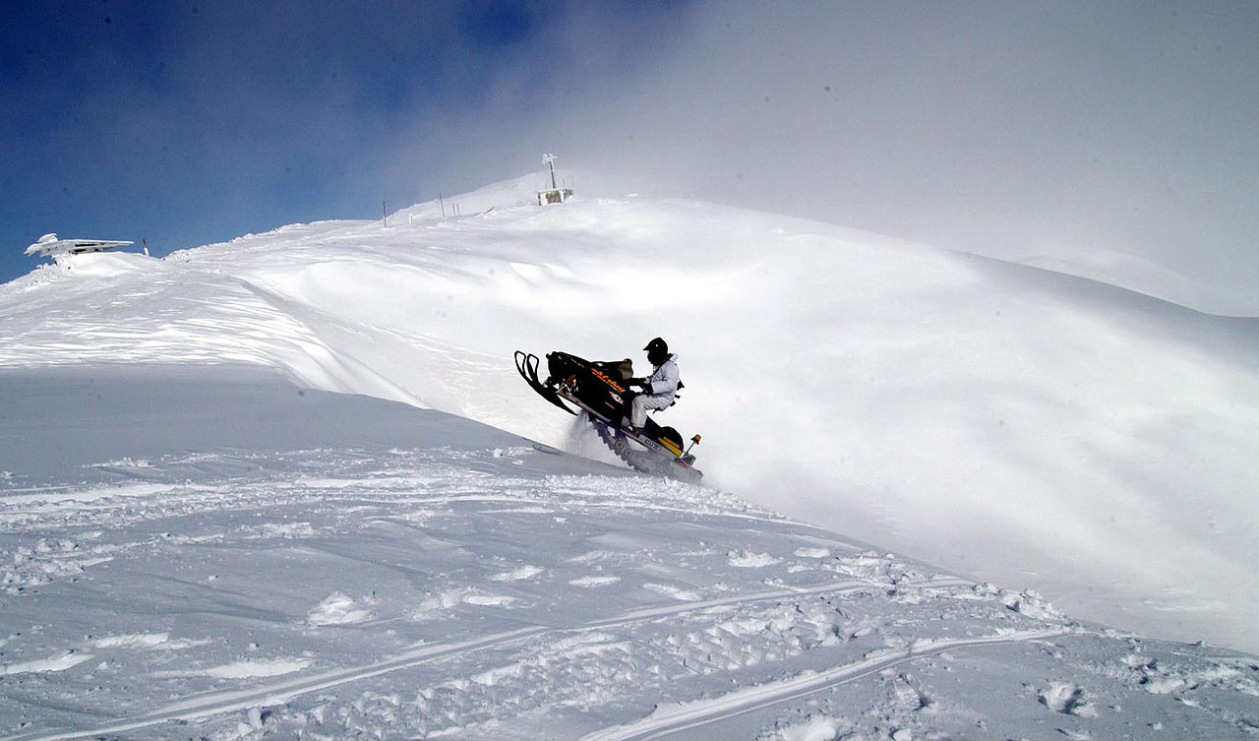

448 NEW HAGUE ROAD HAGUE, NY 12836

NYSSA ID NUMBER (if known) _____________________ On-line registration here: http://nysnowmobiler.com/
First name__________________________________________
Last name_________________________________________
Address______________________________________________
City_____________________ State________ Zip Code_________
Phone #___________________ E-Mail____________________________________________________
(E mail is required for NYSSA in order to send your registration voucher as well as club information and NYSSA newsletters)
Family Member Information:
Spouse: First name___________________ Last Name___________________________________
Children under age of 18
Name_________________________________ Age ____
Name_________________________________ Age ____
Name ________________________________ Age ____
( ) Single or Family membership $30.00 (circle one) S / F
( ) Non rider Hague Sno-Goer member $15.00 (cross country skier/volunteer)
Please indicate if you are a member of another NY snowmobile club _____________________________________________
( ) .25 cents of your dues will be used for NYS Snowmobile PAC who is our voice in Albany. If you do not wish to contribute please check the box.
Signature_____________________________________________ Date _____________________
++++++++++++++++++++++++++++++++++++++++++++++++++++++++++++++++++++++++++++++++++++++++++
For club use only: Blank voucher ID issued_________________________________________
Snowmobile land owner circle one Yes or No

